National Taiwan University of Science and Technology

Graduate Institute of Automation and Control

Thesis Format Guidelines
Items | Structure | Format
Front Cover | Preliminary Matters | National Taiwan University of Science and Technology, name of Graduate Institute, degree type, thesis name, author's name and student number, name of the thesis advisor, submission year and month.
Spine |  | Submission year, National Taiwan University of Science and Technology, degree type, thesis name and author's name.
Title Page |  | National Taiwan University of Science and Technology, name of Graduate Institute, degree type, thesis name, author's name and student number, name of the thesis advisor, submission year and month.
Recommendation Letter from the Thesis Advisor |  | Page numbers are not required.
Thesis/Dissertation Oral Defense Committee Certification
Acknowledgments |  | - -Explain the purpose of your thesis, data resource, the method of study and the results, etc.  - One-page limit.  - 3-5 keywords.  - Acknowledgements, Chinese and English abstracts to the table of contents, etc., page numbers are continuously paged in uppercase Roman numerals such as I, II, III, ....
English Abstract
Table of Contents
List of Figures
List of Tables
Main Text of the Thesis | Text | Use Arabic numerals (-1-, -2-, -3-…) to number the rest of the pages.
References | References | Page numbers are not required. Font style should be Times New Roman and the font size should be 12-point.

- Layout and Binding 【Appendix 1】
Pagination | Page number should be centrally placed at the bottom (1cm) of each page.
Layout Specification | Text Alignment: Justified  Margins: Top: 2.5cm, Left: 3cm, Right: 2.5cm, Bottom: 2.5cm.
Binding | Left binding. After the oral defense, the thesis and dissertation must be properly bound, in the form of a book, either hardback or paperback. Use A4(210mm x 297mm) paper. Front and back cover use 150lb linen paper or carton paper.

Details:

Thesis order:
- Front Cover (Spine)  - Recommendation Letter from the Thesis Advisor  - Thesis/Dissertation Oral Defense Committee Certification  - Acknowledgments  - Abstract and 3-5 keywords | 3.1.6 Table of Contents  - List of Figures  - List of Tables  - Main Text of the Thesis  - References  - Back Cover

  - Preliminary Matters:
      - Cover/Spine Specifications 【Appendix 2】
      - Recommendation Letter from the Thesis Advisor and Thesis/Dissertation Oral Defense Committee Certification https://www.gsac.ntust.edu.tw/p/403-1020-18-1.php?Lang=zh-tw
      - Acknowledgement: One page limit【Appendix 3】
      - ABSTRACT: The content shall contain the key points of the text, including the research purpose, research method, procedure, result, discussion and conclusion. One page limit【Appendix 4】
      - Table of Contents【Appendix 5】
      - List of Figures【Appendix 6】
      - List of Tables【Appendix 7】
      - Font: Times New Roman。
      - Font Size: Except the cover the back cover, the font size is 12
      - Line Spacing: 1.5
      - Title Font Size: 18 / Bold。
EX: ABSTRACT

  - Main Text of the Thesis【Appendix 8】
      - Font and Size: Times New Roman, 12
      - Line Spacing: 1.5。
      - Chapter Title: New Title for each new chapter. Size:18, bold. Do not use abbreviations or punctuation marks in the title.
EX1: Chapter 1 Introduction
      - Section Title: Size: 16, bold. Section and section space: two enters.
EX1: 1.1 XXX
      - Abbreviations: Abbreviations that incorporate periods should not have spaces
EX: "C.N.R.S.", not "C. N. R. S."
      - Units: Use SI (MKS)。English units may be used as secondary units (in parentheses).
EX: “15 Gb/cm2 (100 Gb/in2).”
      - Equations and Symbols:
- Use Microsoft Equation Editor or Math Type add on
(HTTP://www.mathtype.com).
- Be sure that the symbols in your equation have been defined before the equation appears or immediately following.
- Number equations consecutively with equation numbers in parentheses flush with the right margin, as in (1).
EX:

$$∂C/∂(RPP)=H-\left[\sum_{D-RPP/S}^{∞}{f\left(D\right)}\right]bA/Q$$ | (3.2)
$$∂C/∂Q=H/2-σS A/Q-\left[\sum_{D=RPP/S}^{∞}{(SD-RPP)f(D)}\right]bA/Q^{2}$$ | (3.1)

3.3.8 Figures and Charts
a. Size: Width: between 88mm(3.5”) and 181mm(7.16”). Place figures and tables in the center of the page.
b. Display: Number figures/tables consecutively. There is a period after the figure/chart number, followed by two spaces and then the figure/chart title.
EX1: Fig 1.1. Target Group
EX2: TABLE 1.1. PARAMETER SETTINGS
c. Figure/Table Title: Font: Times New Roman, size: 12.
d. Figure/Table Description: Size 9.
e. Resolution: Make sure your image is at 300 dpi.
f. Line Space: The figure/table and context are separated by an enter.
g. Labels: Use words rather than symbols to avoid confusion.
EX:

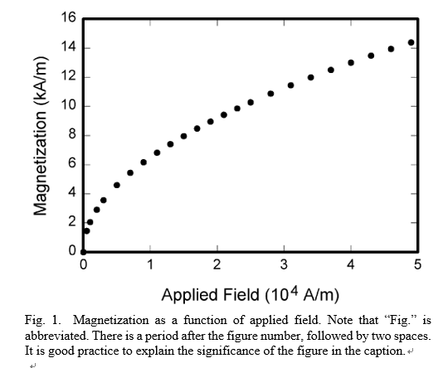

- References【Appendix 9】
- Location: All references cited in the text must appear in the reference list at the end of your paper, starting on a new page
- . Number all reference consecutively at the left margin. Continue page numbers after the main text of the thesis and place in the bottom center.
- Title and Text Font: Times New Roman.
- Title Size: 18, bold.
EX: References
- Text size: 12.
- Line Spacing: 1.5
- Example:

Types | Physical |  | Online
Books | J. K. Author, “Title of chapter in the book,” in Title of His Published Book, xth ed. City of Publisher, (only U.S. State), Country: Abbrev. of Publisher, year, ch. x, sec. x, pp. xx–xx.  Examples:  - G. O. Young, “Synthetic structure of industrial plastics,” in Plastics, 2nd ed., vol. 3, J. Peters, Ed. New York, NY, USA: McGraw-Hill, 1964, pp. 15–64.  - W.-K. Chen, Linear Networks and Systems. Belmont, CA, USA: Wadsworth, 1993, pp. 123–135. |  | J. K. Author, “Title of chapter in the book,” in Title of Published Book, xth ed. City of Publisher, State, Country: Abbrev. of Publisher, year, ch. x, sec. x, pp. xx–xx. [Online]. Available: http://www.web.com  Examples:  - G. O. Young, “Synthetic structure of industrial plastics,” in Plastics, vol. 3, Polymers of Hexadromicon, J. Peters, Ed., 2nd ed. New York, NY, USA: McGraw-Hill, 1964, pp. 15-64. [Online]. Available: http://www.bookref.com.  - The Founders’ Constitution, Philip B. Kurland and Ralph Lerner, eds., Chicago, IL, USA: Univ. Chicago Press, 1987. [Online]. Available: http://press-pubs.uchicago.edu/founders/
Periodicals | J. K. Author, “Name of paper,” Abbrev. Title of Periodical, vol. x, no. x, pp. xxx-xxx, Abbrev. Month, year, DOI. 10.1109.XXX.123456.  Examples:  - J. U. Duncombe, “Infrared navigation—Part I: An assessment of feasibility,” IEEE Trans. Electron Devices, vol. ED-11, no. 1, pp. 34–39, Jan. 1959, 10.1109/TED.2016.2628402.  - E. P. Wigner, “Theory of traveling-wave optical laser,”  Phys. Rev.,  vol. 134, pp. A635–A646, Dec. 1965.  - E. H. Miller, “A note on reflector arrays,” IEEE Trans. Antennas Propagat., to be published. |  | J. K. Author, “Name of paper,” Abbrev. Title of Periodical, vol. x, no. x, pp. xxx-xxx, Abbrev. Month, year. Accessed on: Month, Day, year, DOI: 10.1109.XXX.123456, [Online].  Examples:  - J. S. Turner, “New directions in communications,” IEEE J. Sel. Areas Commun., vol. 13, no. 1, pp. 11-23, Jan. 1995.  - W. P. Risk, G. S. Kino, and H. J. Shaw, “Fiber-optic frequency shifter using a surface acoustic wave incident at an oblique angle,” Opt. Lett., vol. 11, no. 2, pp. 115–117, Feb. 1986.  - P. Kopyt et al., “Electric properties of graphene-based conductive layers from DC up to terahertz range,” IEEE THz Sci. Technol., to be published. DOI: 10.1109/TTHZ.2016.2544142.
Reports | J. K. Author, “Title of report,” Abbrev. Name of Co., City of Co., Abbrev. State, Country, Rep. xxx, year.  Examples:  - E. E. Reber, R. L. Michell, and C. J. Carter, “Oxygen absorption in the earth’s atmosphere,” Aerospace Corp., Los Angeles, CA, USA, Tech. Rep. TR-0200 (4230-46)-3, Nov. 1988.  - J. H. Davis and J. R. Cogdell, “Calibration program for the 16-foot antenna,” Elect. Eng. Res. Lab., Univ. Texas, Austin, TX, USA, Tech. Memo. NGL-006-69-3, Nov. 15, 1987. |  | J. K. Author. “Title of report,” Company. City, State, Country. Rep. no., (optional: vol./issue), Date. [Online] Available: site/path/file  Examples:  - R. J. Hijmans and J. van Etten, “Raster: Geographic analysis and modeling with raster data,” R Package Version 2.0-12, Jan. 12, 2012. [Online]. Available: http://CRAN.R-project.org/package=raster  - Teralyzer. Lytera UG, Kirchhain, Germany [Online]. Available: http://www.lytera.de/Terahertz_THz_Spectroscopy.php?id=home, Accessed on: Jun. 5, 2014
Online Conference Paper | / |  | J.K. Author. (year, month). Title. presented at abbrev. conference title. [Type of Medium]. Available: site/path/file  Example:  - PROCESS Corporation, Boston, MA, USA. Intranets: Internet technologies deployed behind the firewall for corporate productivity. Presented at INET96 Annual Meeting. [Online]. Available: http://home.process.com/Intranets/wp2.htp
Patents | J. K. Author, “Title of patent,” U.S. Patent x xxx xxx, Abbrev. Month, day, year.  Example:  - G. Brandli and M. Dick, “Alternating current fed power supply,” U.S. Patent 4 084 217, Nov. 4, 1978. |  | Name of the invention, by inventor’s name. (year, month day). Patent Number [Type of medium]. Available: site/path/file  Example:  [21] Musical toothbrush with mirror, by L.M.R. Brooks. (1992, May 19). Patent D 326 189  [Online]. Available: NEXIS Library: LEXPAT File: DES

Layout
 | 25cm 21cm
 | 3cm  Reserve 1cm  For Binding | 1. Solid line represents paper size 21×29.7 cm（A4 size）  2. Dotted line represents text range  3. Margins: Top/Left/Bottom: 2.5cm,  Left: 3cm (reserve 1 cm for binding) | 2.5cm
 |  | 1cm -XX- 2.5cm
Appendix 1
國立臺灣科技大學
自動化及控制研究所
碩士學位論文
Appendix 2
XXXXXXXXXXXXXX
(Times New Roman, 22pt)
Graduate Student: XXX
Student ID Number：XXXXXXXX
Advisor：Dr. XXX

2020
109
National Taiwan University of Science and Technology
Graduate Institute of Automation and Control
Master’s
Thesis
Title: XXXXXXXX
Name: XXX
Appendix 2

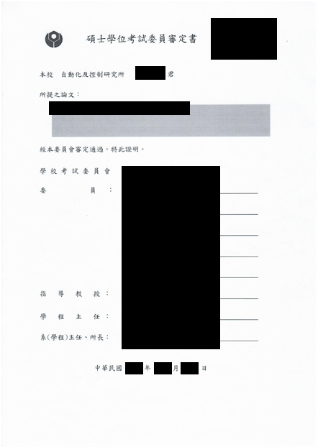

Acknowledgment
Appendix 3

First of all, XXXX XXXXXXXXXXXXXXXXXXXXXXXXXXXXXXX。 XXXXXXXXXXXXXXXXXXXXXXXXXXXXXXXXXXXXXXXXXXXXXXXXXXXXXXXXXXXXXXXXXXXXXXXXXXXXXXXXXXXXXXXXXXXXXXXXXXXXXXXXXXXXXXXXXXXXXXXXXXXXXXXXXXXXXXXXXXXXXXXXXXXXXX

ABSTRACT
Appendix 4

Overlay metrology is a crucial process in the advanced process nodes of semiconductor manufacturing. Accurately measuring the overlay between the process layers effectively reduces the rework rate. Diffraction based overlay (DBO) is regarded as a critical overlay metrology technique, it can place the dedicated overlay targets in the wafer fields for XXXXXXXXXXXXXXXXXXXXXXXXXXXXXXXXXXXXXXXXX

Keywords:

Table of Contents
Appendix 5

Acknowledgement I
ABSTRACT II
Table of Contents III
List of Figures IV
List of Tables V
Chapter 1 XXX 1
1.1 XXX 1
1.2 XXXX 1
1.3 XXXX 1
1.4 XXXX 1
Chapter 2 XXXX 2
2.1 XXX 2
2.2 AAAAAA 2
2.3 BBBBBBB 2
2.4 CCCCCCC 2
2.5 XXX 2
Chapter 3 XXXX 2

List of Figures
Appendix 6

Fig. 1.1. XXXX 1
Fig. 2.1. XXXXX 10
Fig. 2.2. XXXXX 11

List of Tables
Appendix 7

TABLE 1.1. International XXX 2
TABLE 1.2. XXX 5
TABLE 1.3. XXX 6
TABLE 3.1. XXX 27

Chapter 1 XXXXX
Appendix 8

1.1 XXX
XXXXXXXXXXXXXXXXXXXXXXXXXXXXXXXXXXXXXXXXXXXXXXXXXXXXXXXXXXXXXXXXXXXXXXXXXXXXXXXXXXXX.

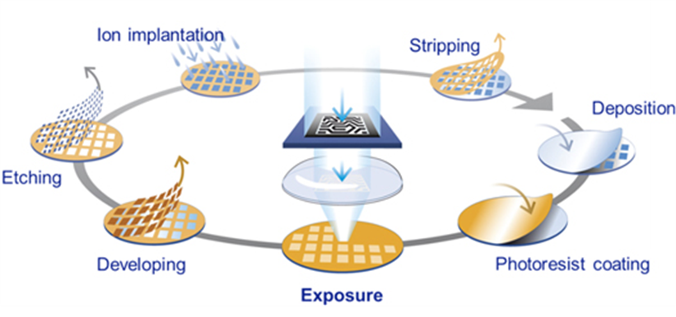
Fig. 1.1. xxxxxxxxxxxxxxxxxx

XXXXXXXXXXXXXXXXXXXXXXXXXXX (Photoresist Coating)、 (Exposure)、(Developing)and (Etching) [3]。XXXXXXXXXXXXXXXXXXXXXXXXXXXXXXXXXXX。

1.2 XXXXXX
XXXXXXXXXXXXXXXXXXXXXXXXXXXXXXXXXXXXXXXXXXXXXXXX．

(1.1)

1.3 XXXXX
XXXXXXXXXXXXXXXXXXXXXXXXXXXXXXXXXXXX.

TABLE 1.1. XXX
XXX | PCB | xx | TFT-LCD
xxx | 25~30 [um] (5G) | 1~2 [um] (xxx) | 2 [um]
xxx | 588m(USD) | xxx(USD) | xx(USD)

XXXXXXXXXXXXXXXXXXXXXXXXXXXXXXXXXX，shown as TABLE 1.1.

References
Appendix 9

[1] G. O. Young, “Synthetic structure of industrial plastics,” in Plastics, 2nd ed., vol. 3, J.Peters, Ed. New York, NY, USA: McGraw-Hill, 1964, pp. 15–64.

